Яковлев Евгений

РИМ-181228

# Compiling srouces

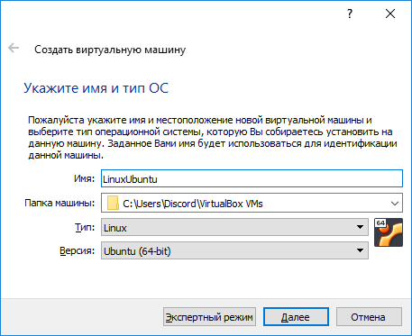

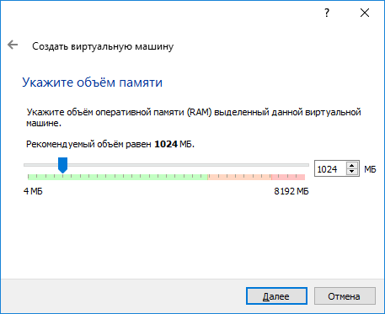 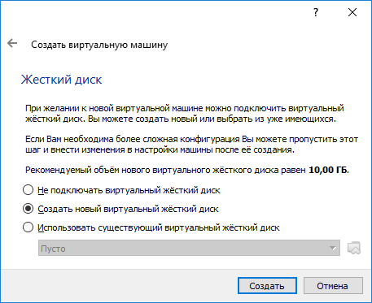

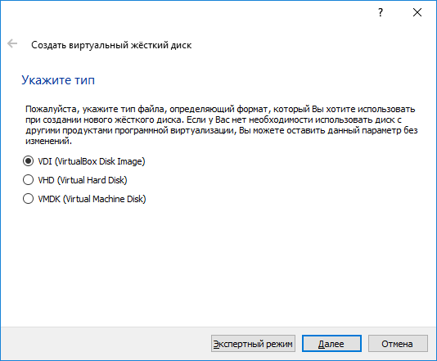

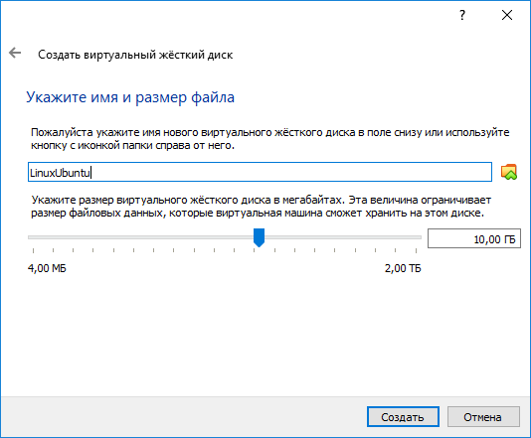

 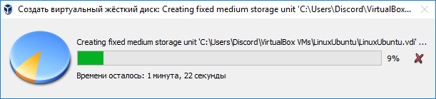

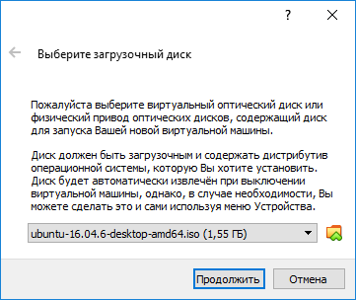

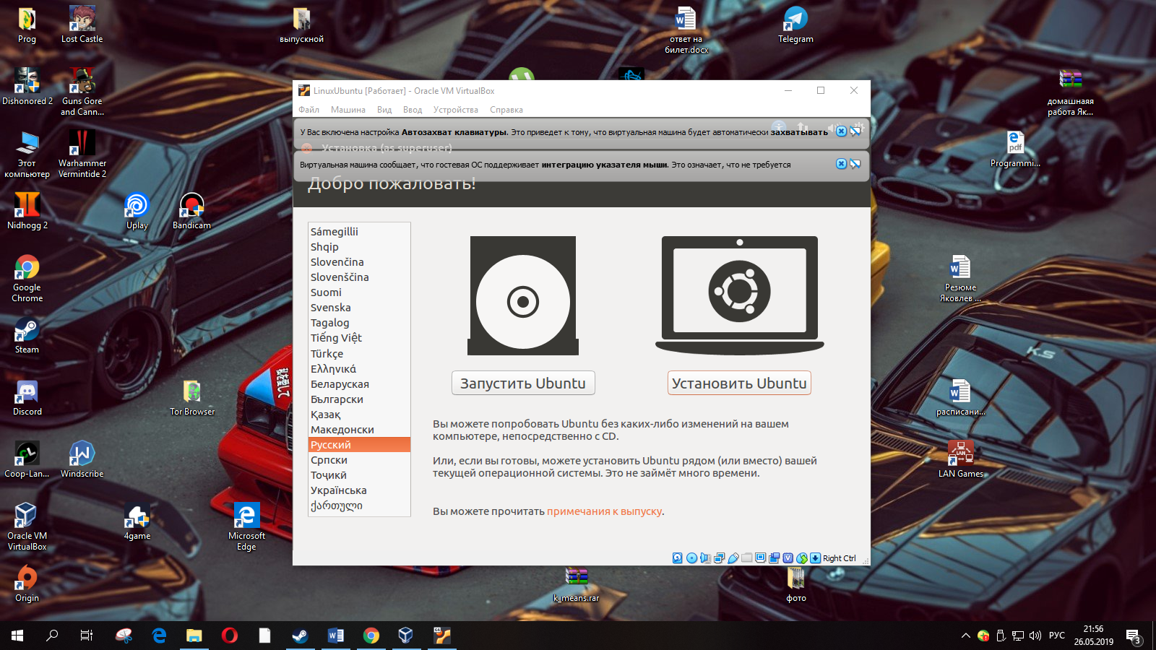

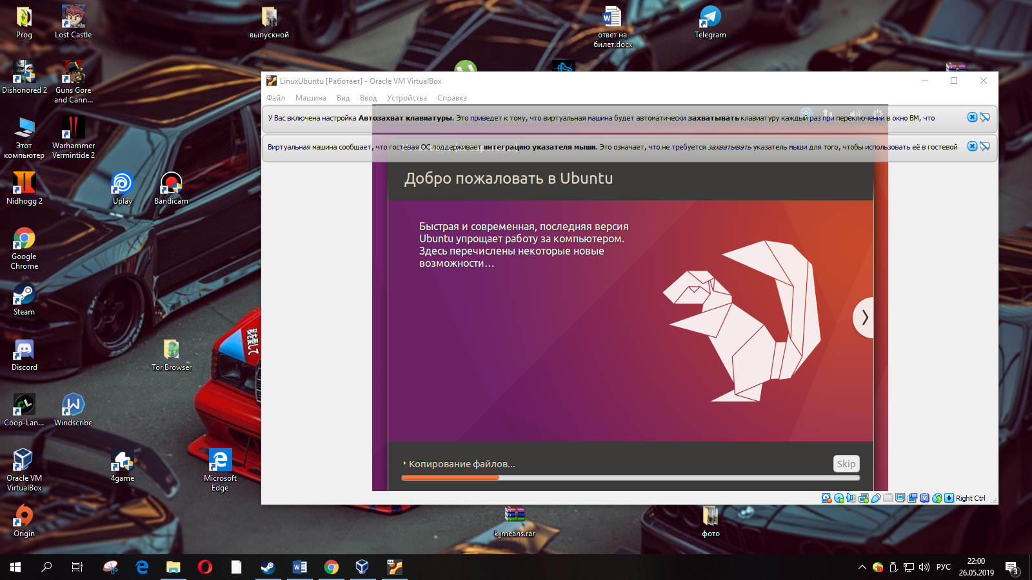

Finish and start your VM.

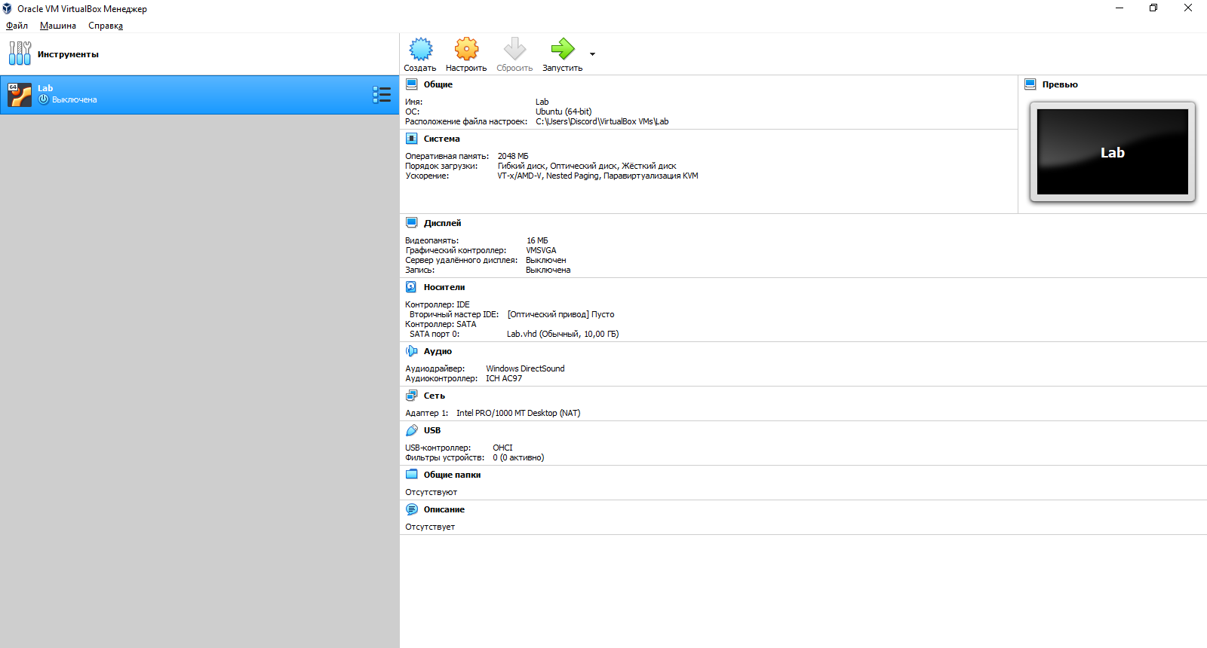

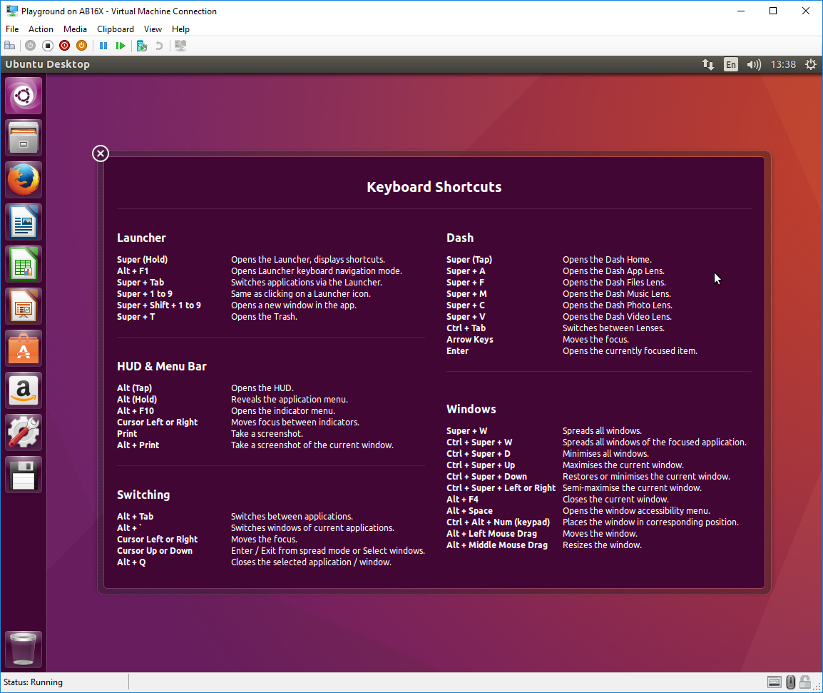

Let’s proceed to PostgreSQL source code download.

## Compiling PostgreSQL source code

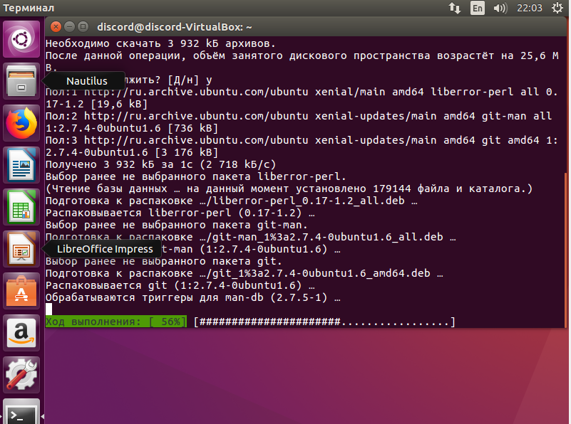

Go to GitHub and make a fork of the PostgreSQL repository to your account

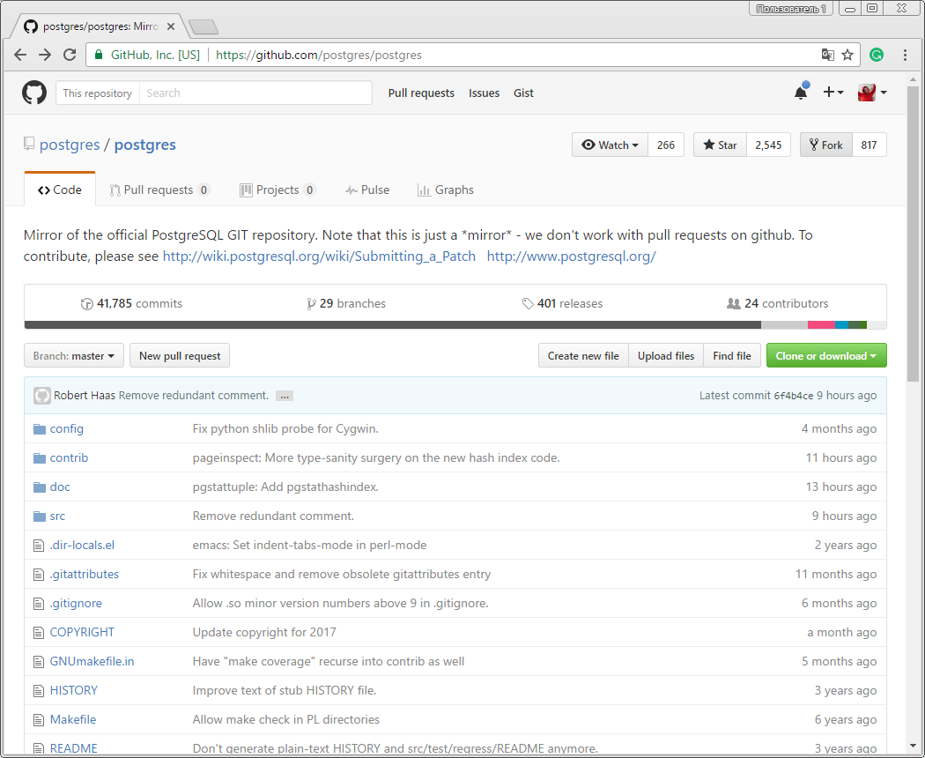

Open new terminal and type:

mkdir project

cd project

git clone [https://github.com/[your name on github]/postgres](https://github.com/%5byour%20name%20on%20github%5d/postgres%20)

mv postgres pgsql

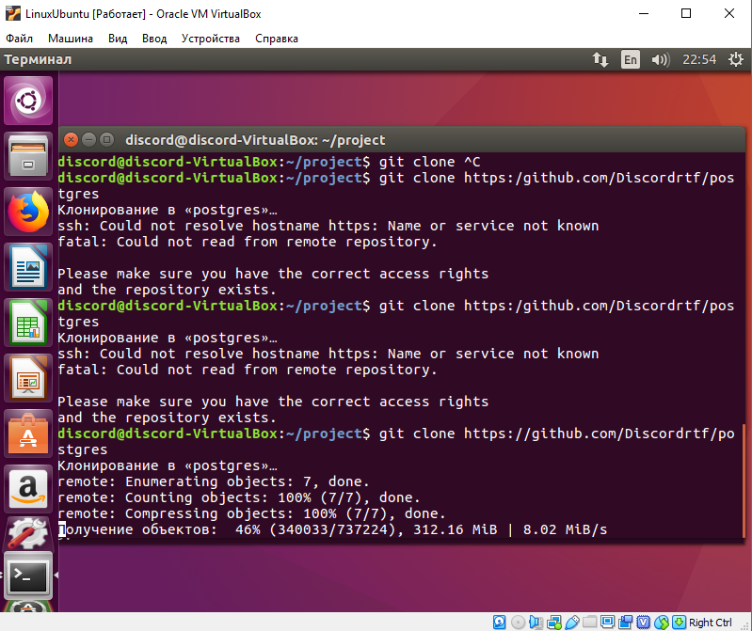

The process will take some minutes to complete. You can open one more terminal and prepare PostgreSQL preprequisites:

sudo apt-get install build-essential libreadline-dev zlib1g-dev flex bison libxml2-dev libxslt-dev libssl-dev

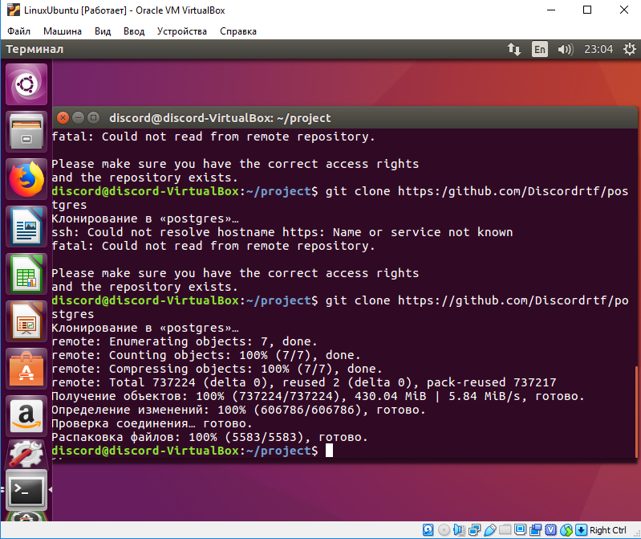

https://wiki.postgresql.org/wiki/Compile_and_Install_from_source_code

Both processes are quite time consuming.

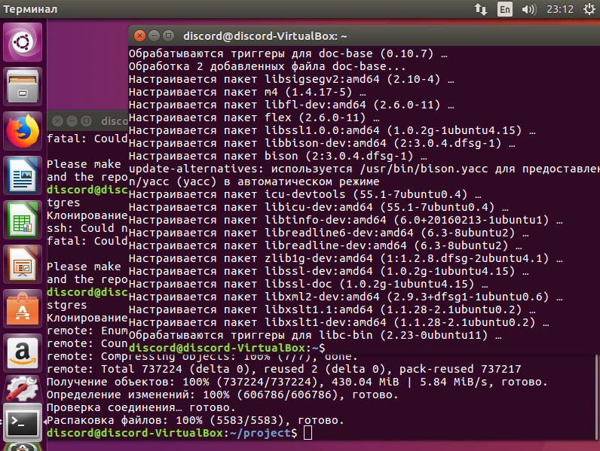

When All is done you can take a snapshot of VM.

Checkout branch REL9_6_STABLE

cd pgsql

git checkout REL9_6_STABLE

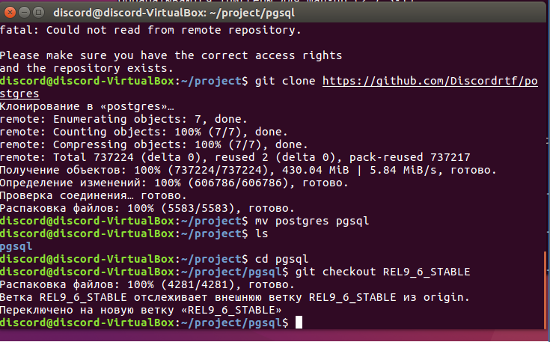

This is not necessary when you do a real development, usually you apply your patches over master branch.

Make your dev branch

git checkout -b temp1

and send your branch to github

git push origin -u temp1$

Now you are ready to configure your code.

./configure --prefix=$HOME/project --enable-depend --enable-cassert --enable-debug

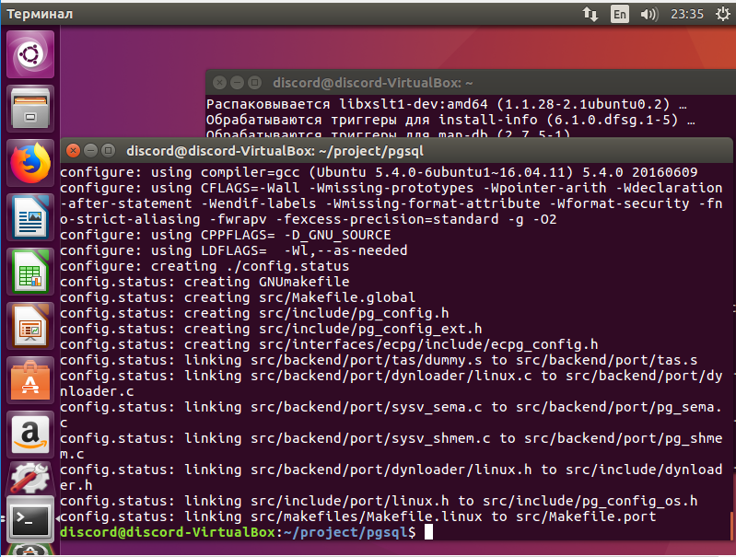

Now you are ready to compile your sources, type

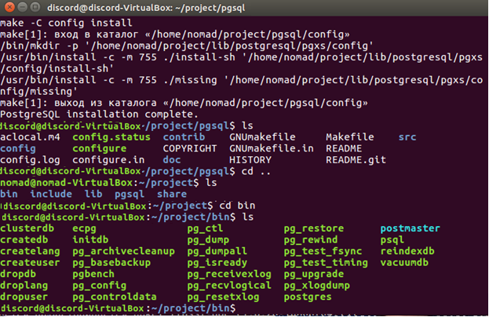

To let the system search your commands here type

export PATH=$HOME/project/bin:$PATH

To let your default DB be here too

export PGDATA=$HOME/project/DemoDb

And now you can initialize your database by typing

initdb

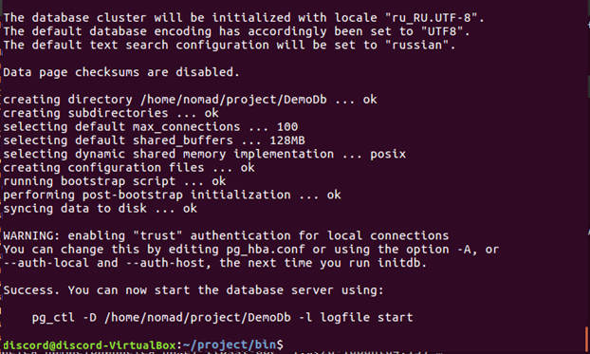

Change directory to DemoDb and run

nano PG_VERSIO

It will display your version. What version do you have now?

9.6

Nano is the simplest tool to edit files. Now quit nano.

Start the server by

./postgres -D ~/project/DemoDb

